THE ROYAL COLLEGE
SUMMER HOLIDAY HOMEWORK
2019-2020
CLASS – 9th
Dear Parents,
PLEASE MAKE YOUR WARD COMPLETE THEIR HOLIDAY HOMEWORK IN NEAT AND SYSTEMATIC WAY BECAUSE IT CARRIES 20 MARKS IN EACH SUBJECT FOR ASSESSMENT.
MAKE A PRESENTATION IN POWER POINT ON THE TOPIC GIVEN BY YOUR TEACHER WITH IMAGE OR PICTURES IN SIMPLE LANGUAGE OF AT LEAST 8 SLIDES AND AT MOST 12 SLIDES.

Complete the following in separate notebook.
ENGLISH:
(Section –A) Beehive.
Answer the following questions.
- What did the County Inspector do to improve Margie’s performance in geography?
- Evaluate ‘The Fun they had’ as a futuristic story?
- How will the e-books be different from the old books that existed centuries ago?
- What did Margie’s mother think about ‘the teacher’ and ‘the school’?
- Why did Margie hate the mechanical teacher?
- How did Margie and Tommy express their feelings about the real book?
- What sort of pipe did the barber choose?
- Why did Emperor Aurangzeb banned pungi?
- How was Evelyn determined to lead a mortal life?
- What was Bismillah Khan’s tenure in the film-world? Why did he leave the world of films?
- How has Evelyn Glennie become a source of inspiration for those who are handicapped?
- Why was Kezia’s father too upset?
- Why did Kezia’s father come with a ruler in his hands?
- Why couldn’t her father be Mr. Macdonald?
- What did Kezia regret?
- Why did her father intend to punish her?
- Which incident changed Kezia’s opinion about her father’s behaviour?
- Did Kezia ever stutter with other people? Why or Why not?
- How can you say that punishments given by parents hold love for you?
- The children must understand their parents in the true sense. How?

(Section –B) Poetry
- What does the road represent?
- Did the poet take his decision haphazardly?
- In the poem ‘The Road Not Taken’, what do the woods symbolize?
- Where does the traveler find himself?
- What was the poets’ dilemma?
- Did the poet make the right choice?
- Give a character sketch of Robert Frost?
- What can the wind do?
- Who are disturbed by the wind?
- Why does the author ask the wind to come swiftly?
- What are the things the wind does in the first stanza?
- Why does the poet suggest the people that they have to be strong?
- What moral lesson do you get from the poem ‘The Wind’?
- How can you say that friendship with the strong is good?
- Describe the significance of good decision. In what manner do they support life?
- Write in detail about the author Subramania Bharati?
- Write a short summary of the chapter ‘The Fun They Had’?
- Give the character sketch of Deborah Cowley?
- Write the theme of the story ‘The Sound of Music’?
- Write a short note on Bismillah khan from the chapter ‘The Shehnai of Bismillah Khan’?

(Section –C ) Supplementary.
01.Read chapter no:- 1 to 6, underline at least 30 difficult words from each
chapter and find their meanings with the help of the dictionary.
02. Make 50 good sentences from the same words.

(Section –D) Grammar.
- Write a letter to your friend telling him about the fun you had during the vacation in Shimla.
- Write a letter to the principal of your school requesting him/her to enroll your name for the school cricket team.
- Write an article on the topic, ‘Gadgets Curse or Boon for Students’ in about 80 words.
- Learn the ‘Parts of Speech’, and write the definitions with 3 examples each.

Dear Royales,
Please note that. All the work has to be done neatly, clearly and it should be free from all errors. The work done by you should be revised and learned well by you, as you will be asked to explain the same in class.
While returning back after the vacations, carry a English to English dictionary with you to school.

HINDI: Complete all the questions in separate notebook.

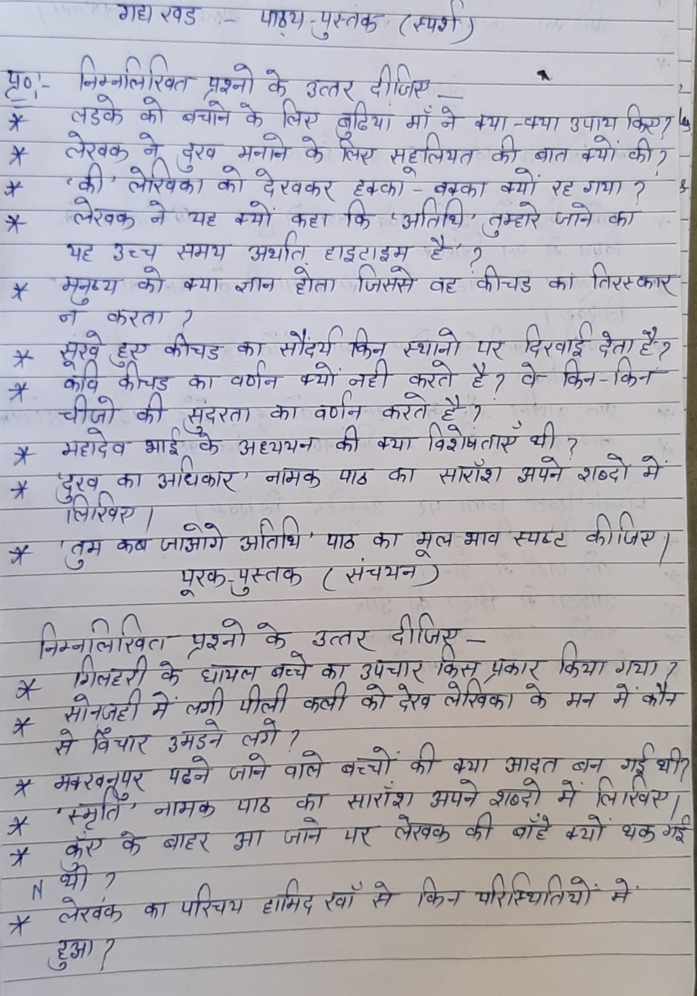
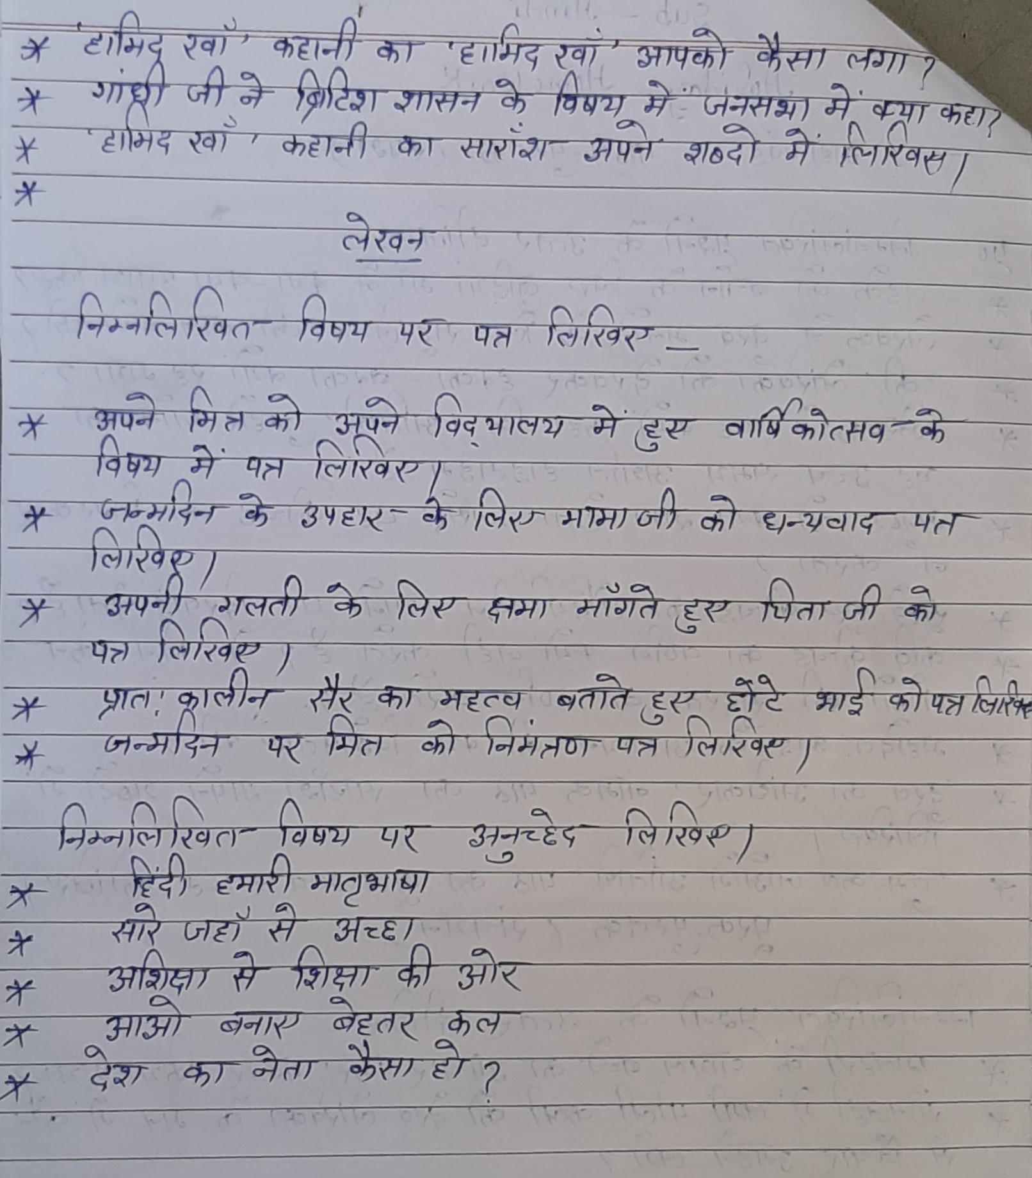
MATHS:
NOTE: Do in a separate notebook.
- Practice chapter 2, 3, 4, 12.
NOTE: All the examples and exercise questions.
Q1 Solve:
- (√2x – 3y)²
- (x/2 – y/3)²
- (x + 5)(x - 3)
- (3x – 4y)²
- (x-1)(x+1)(x²+1)(x⁴+1)
- 185 * 185 – 115 *115
- 105 * 106
Q 2 If x + 1/x = 6, find
- x² + 1/x²
- x⁴ + 1/x⁴
Q3 If x² + 1/x²= 27, Find
- x + 1/x
- x - 1/x
Q4 If x+y = 12 and xy= 32, find the value of x² + y².
Q5 Prove that:
2a²+2b²+2c²-2ab-2bc-2ca = [(a-b)²+(b-c)²+(c-a)²]
Q6 If a²+b²+c²-ab-bc-ca = 0, prove that a=b=c.
Q7 Simplify: (a+b+c)² + (a-b-c)²
Q8 Prove that:
- (a+b)³ = a³+b³+3ab(a+b)
- (a-b)³ = a³-b³-3ab(a-b)
Q9 Factorize by splitting the middle term:
- x²+3√3x+6
- x²+3√3x-30
- 4√3x²+5x-2√3
- 5√5x²+30x+8√5
- 7√2x²-10x-4√2
Q10 Factorize:
- x³+3x²+3x-7
- x³-3x²+3x+7
- x³+6x²+12x+16
Q11 Divide:
- p(x)= x⁴-3x²+2x+5, g(x)= x-1
- p(x)= x³+x²+2x+3, g(x)= x+2
Q12 Plot on the graph paper and write the quadrant and axes in which they lies:
- (2,5)
- (4,-3)
- (-5,-7)
- (7,-4)
- (-3,2)
- (7,0)
- (-4,0)
- (0,7)
- (0,-4)
- (0,0)
Q13 Fill in the blanks
- The point of intersect of the coordinate axes is ___________________.
- The abscissa and ordinate of the origin are __________.
- The measure of the angle between coordinate axes is _________.
- A point whose abscissa and ordinate are 2 and -5 respectively lies in _________ quadrant.
- Point (-4,0) and (7,0) lies on _______.
- The ordinate of any point on x-axis is ______.
- The abscissa of any point on y-axis ________.
- The abscissa of a point is positive in the _____ and _______ quadrant.
Q14 Draw the graph of 2x+y=6 and 2x-y+2=0. Shade the region bounded by these lines and x-axis. Find the area of shaded region?
Q15 Draw the graph of x-y=1 and 2x+y=8. Shade the region bounded by these lines and y-axis. Find the area of shaded region?
Q16 A three-wheeler scooter charges Rs. 15 for first kilometre and Rs. 8 each for every subsequent kilometre? Write linear equation for this?
Q17 Solve 2x+1=x-3 and represent the solutions on
- The number line
- The cartesian plane
Q18 Two parallel sides of a trapezium are 60 cm and 77cm and other sides as 25 cm and 26 cm. Find the area of trapezium?
Q19 Find the area of quadrilateral ABCD in which AD=24 cm, angle BAD= 90⁰and BCD forms an equilateral triangle whose each side is equal to 26 cm.
Q20 Find the area of quadrilateral ABCD in which AB= 42 cm, BC= 21cm, CD= 29 cm, DA= 34cm and BD= 20cn.
Q21 Find the area of rhombus whose perimeter is 80 cm and one of the diagonal is 24 cm.
Q22 Rationalise :-
- 5
√3-√5
- 2√7
√11
- 7+3√5
7-3√5
- 5+√6
5-√6

Q23 Evaluate:-
- (64)^{1/3}
- (27)^{-2/3}
- (125)^{-1/3}
- (64/25)^{-3/2}
Q24 Simplify:
- 5²× 5⁴
- 5⁸ ÷ 5³
- (3²)³
- (11/12)³
- (3/4)⁻³
Q25 Simplify:-
- (81/16)^{-3/4} × [(25/9)^{-3/2} ÷ (5/2)⁻³]
- (2/11)⁴×(11/3)²×(3/2)³
- (1/2)⁵×(-2/3)⁴×(3/5)⁻¹
- 2⁵⁵×2⁶⁰-2⁹⁷×2¹⁸
- (2/3)²×(2/5)⁻³×(3/5)²
SCIENCE:
- a. What is motion?
b. State the types of motion?
c. Write the unit of acceleration?
- Derive the first equation of motion?
- A car moves with the velocity of 30km/h for 30min, 25km/h for 25min and 40km/h for 2h. calculate the average speed of the car?
- Give one example of each of the following:
- Uniformly accelerated motion.
- Motion with uniform retardation.
- Accelerated motion with uniform magnitude of velocity.
- Motion in a direction with acceleration in perpendicular direction.
- Motion in which v-t graph is a horizontal line parallel to X-axis.
- Derive the second equation of motion?
- Draw a velocity time graph of a stone thrown vertically upwards and then coming downwards after attaining the maximum height?
- Derive the third equation of motion?
- Derive the first equation of motion by Graphical method?
- Derive the second equation of motion by Graphical method?
- Derive the third equation of motion by Graphical method?
- What would happen if a fielder stops the fast moving ball suddenly? Justify your answer.
- Answer the following
- Explain why it is difficult to walk on sand?
- Why the recoil of the heavy gun, on firing, not so strong as that of light gun using the same cartridge?
- What is momentum? Write its SI unit. Interpret force in terms of momentum. Represent the following graphically:
- Momentum versus velocity when mass is fixed.
- Momentum versus mass when the velocity is constant.
- Give reason for the following question:
- It is difficult to balance our body when we accidently step on a peel of banana.
- Pieces of bursting cracker fall in all possible direction.
- A glass pane of a window is shattered when a flying pebble hits it.
- It is easier to stop a tennis ball than a cricket ball moving at the same speed.
- A javelin thrower is marked foul, if an athlete crosses over the line marked for the throw. Athletes often fail to stop themselves before the line.
- Answer the following:
- When the carpet is beaten with a stick dust comes out of it. Explain.
- Calculate the force required to impart a car with a velocity of 30m/s in 10s starting from rest. The mass of the car is 15000kg.
- Explain the newton’s first law of motion.
- Explain the newton’s second and third law of motion.
- Explain Universal law of gravitation.
- Give out the difference between mass and weight.
- What are the scalar and vector quantities? Explain the following physical quantities.
- Distance.
- Displacement.
- Speed.
- Velocity.
- Acceleration.
- Answer the following:
- A sponge can be compressed, yet it is a solid? Explain.
- Name the state of matter that has minimum space between the particle.
- Answer the following:
- Explain the interconversion of three states of matter in terms of force of attraction and kinetic energy of the molecules.
- Arrange the three states of matter in the increasing order of rate of diffusion and particle motion.
- What is dry ice? How is it formed?
- Explain the terms density. Arrange different states of matter in increasing order of density.
- Explain how ice floats on water.
- Define solute and solvent. Is it possible to separate them?
- While diluting a solution of salt in water, a student by mistake added acetone (boiling point 56℃). What technique can be employed to get back the acetone? Justify your choice.
- Can a physical and chemical changes occur together? Illustrate your answer.
- Show diagrammatically how water is purified in the water work system and list the processes involved.
- Write the steps involved in the process of obtaining pure copper sulphate from an impure sample. Give one example of this method.
- Who discovered cell and how?
- Why is the cell called the structural and functional unit of life?
- Which organelle is known as the powerhouse of the cell?why?
- Describe the phenomenon of membrane biogenesis. Give one function of ER.
- Why lysosomes are known as ‘scavengers of the cell’? Lysosomes are self-destructive. Give reason.
- Describe an activity to demonstrate endosmosis and exosmosis. Draw the diagram also.
- Draw the neat labelled diagram of animal cell. Name the structure, which helps in energy production and lipid synthesis?
- Why are mitochondria called the powerhouse of the cell? Give three similarities and one difference between mitochondria and plastid.
- Explain the main functional regions of a cell with the help of a diagram.
- How are the following related to each other ?
- Chromatin network and chromosomes
- Chloroplast and chlorophyll
- Genes and DNA

SST:
Q1 How was multiple cropping practised in Palampur?
Q2 Explain Physical capital, Fixed capital and Working capital?
Q3 Differentiate between traditional and modern methods of farming?
Q4 What is Production? State any four requirements needed for production of goods and services?
Q5 Explain Primary sector and Secondary sector ?
Q6 What do you understand by people as resource ?
Q7 Why are women employed in low paid work?
Q8 What is disguised unemployment?
Q9 Define seasonal unemployment ?
Q10 Sarva Shiksha Abhiyan is meant to provide what kind of education?
Q11 What is market activities and non market activities?
Q12 Describe five unfavourable effects of population growth in a country like India?
Q13 Explain the case of Pakistan?
Q14 Explain any five effects of unemployment in India?
Q15 What is democracy?
Q16 What are the difficulties people face in non democratic countries?
Q17 Why do we need a constitution? Give any five reasons?
Q18 What was Apartheid?
Q19 What is constitution?
Q20 Why do we need meridian?
Q21 India has a long coastline which is advantageous? Explain two advantage?
Q22 Give a brief account on the size of India?
Q23 How does democracy improve the quality of decision making?
Q24 Which three rights should every citizen of a democratic country get?
Q25 Explain any three suggestions to reduce unemployment?
NOTE:
Make a separate notebook for the question and answer.
Prepare the Power Point presentation for about 10 to 12 slides.
STUDENT TOPIC
- Alisha Wesley Our Parliament
- Ansh Chauhan Wildlife Conservation
- Arya Kumari What is our system of election?
- Avantika Sharma Biography of Adolf Hitler
- Bharat Chauhan Role of Rivers in economy
- Cheerag Roy General points of French Revolution
- Daksh Sharma Unemployment
- Gayatri Ghosh Natural Vegetations
- Kanika Sharma Natural Disaster
- Manan Chauhan Pollution of Rivers
- Mandeep Singh Rise of Napoleon Bonaparte
- Mohd. Asraf Ali Farming in Palampur
- Nisha Bharati Duties of IAS officer
- Nishant Tomar Making of Parliament
- Oshank Bhandari The Indian Monsoon
- Prajjwal Poverty (estimate and cause)
- Pranav Dixit Physical features of India
- Raghav Kukshal Democracy (define and features)
- Rishuraj Singh Our Parliament
- Rupinder Singh Election in India (democratic)
- Shruti Tomar Ganga rejuvenation schemes and plans
- Soumen Chaudhary Life without democratic rights
- Vansh Gupta Three main organs of government
- Vansh Rastogi Different types of forest in India
- Vinayak Gupta National Park and Wildlife Sanctuary
- Yatharth Chauhan Our Parliament
- Sandra D’souza Natural Disaster
- Anjali Kumari The Indian Monsoon
- Daksh Jha Wildlife Conservation
- Bhavya Chugh Pollution of rivers
- NitiLakshya Food security in India
- Abhinav Jain Roles of rivers in economy
- Rounak Sharma Sarva Siksha Abhiyan
- Raj Aryan How to prepare for Civil Services
- Hardik Tuteja Pollution of rivers
- Aryashree Our system of election
- Priyanshi Sehwag Making of Indian Constitution
- Surya Pratap Yadav Natural Disaster
- Anmolpreet Kaur Rights in Indian Constitution
- Manvi Bharadwaj Powers and duties of President and P.M.

NOTE: Do one good deed daily and write about it in a separate scrap book.
For any query you can call to Mr. Rahul Khanna on this number +917895026334 only between 10.30am to 11.30am

