THE ROYAL COLLEGE
SUMMER HOLIDAY HOMEWORK
2019-2020
CLASS – X
Dear Parents,
PLEASE MAKE YOUR WARD COMPLETE THEIR HOLIDAY HOMEWORK IN NEAT AND SYSTEMATIC WAY BECAUSE IT CARRIES 20 MARKS IN EACH SUBJECT FOR ASSESSMENT.
Complete the following in separate notebook.
ENGLISH:
(Section-A) First Flight
Answer the following questions
- Explain the qualities of the post office employees?
- Why would you not agree with Lencho calling the post office employees ‘a bunch of crooks’?
- How did Lencho react to the post master’s help?
- What do you mean by the word ‘resolution’?
- What did Lencho write in his letter to God? Who received his letter and what did he do?
- ‘I wish I had the faith of that man who wrote this letter’. Describe Lencho’s character in the light of this statement.
- What ceremonies were held on tenth May?
- Who have been called ‘Outlaws’ and why?
- What type of government was chosen in South Africa?
- What harm was caused by the policy of apartheid?
- What does Mandela refer to as ‘an extraordinary human disaster’?
- What twin obligations does Mandela mention?
- Why does Mandela call himself the sum of all those African patriots who had gone before him?
- What does Mandela mean by ‘transitory freedoms’?
- ‘I was not born with a hunger to be free’. When did Mandela begin to hunger for it ?
- Describe the scene that the seagull saw on the plateau across the ledge.
- Did the seagull think the sea was like land? Pick out the words that suggest this.
- Write a note on the title of the story, ‘His First Flight’. Can you suggest some other suitable titles?
- Do you agree that the story told in ‘The Black Aeroplane’ is a mystery? Justify your answer.
- How was the pilot of the old Dakota rescued?
- Explain the statement : ‘I was very happy to go behind the strange aeroplane like an obedient child’.
- Was the pilot of the Dakota able to meet the pilot of the black aeroplane?
- What makes writing in a diary a strange experience for Anne Frank?
- Why does Anne provide a brief sketch of her life?
- Why was Mr. Keesing annoyed with Anne? What did he ask her to do?
- When did her father emigrate to Holland?
- Why does the writer call herself ‘a birthday present for Margot’?
- ‘Paper has more patience than people’. Elucidate.
- Where Did Anne stay before going to Holland ?
- Why did Anne think that she was alone ?
- Was Anne an intelligent girl? Give instances in support of your answer.
- How did Anne finally stop Ms.Keesing from punishing her?
- Write a short paragraph on Anne’s character.
- In what way was Wanda was different from the other chidren?
- Is Mrs. Mason angry with the class,or is she unhappy and upset?
- What are Maddie’s thoughts as they go to Boggins heights?
- What does Maddie think hard about ? what important decision does she come to ?
- In what way was Wanda different from the other children?
- Did Wanda have hundred dresses ? Why do you think she said she did ?
- Give a brief sketch of Wanda,Peggy,Maddie.

(Section –B) Poetry

- Describe briefly the scene described by frost in his poem ‘Dust of Snow’.
- How does Frost say his mood has changed?
- Explain the symbols used by Frost in his poem ‘Dust of Snow’
- A simple moment proves to be very significant and saves the rest of the day of the poet from being wasted . Explain on the basis of the poem ‘Dust of Snow’.
- Write a detailed character sketch of Robert Frost.
- Discuss the theme of the poem , ‘Fire and Ice’.
- What is the poets view about the end of the world?
- Give a brief substance of the poem ‘Fire and Ice’.
- Why do you think he should be snarling around the houses ?
- Why does he express his anger quietly?
- How does the poet contrast a tiger in its natural habitat and in a cage ?
- Briefly summarize the poem, ‘How to tell the wild animals’.
- What is that ‘every man must one day know?’
- What idea does the poet want to convey in this poem?
- What picture of Amanda do you form from the poem, ‘Amanda’?
- Is Amanda an orphan ? why does she say that?
- Write a paragraph about the poet ROBIN KLEIN.
- What do you know about Joha Berryman? Write in details.
- Give a character sketch of Carolyn Wells.
- Write briefly the summary of ‘A letter to God’.

(Section –C ) Supplementary
Read ch.1-7 and make 10 objective type Q/A from each chapter . Underline 10 D/M from each chapter.Make 30 sentences from the same words.

Dear Royales,
Please note that. All the work has to be done neatly, clearly and it should be free from all errors. The work done by you should be revised and learned well by you, as you will be asked to explain the same in class.
While returning back after the vacations, carry a English to English dictionary with you to school.

HINDI: Complete all the questions in separate notebook.

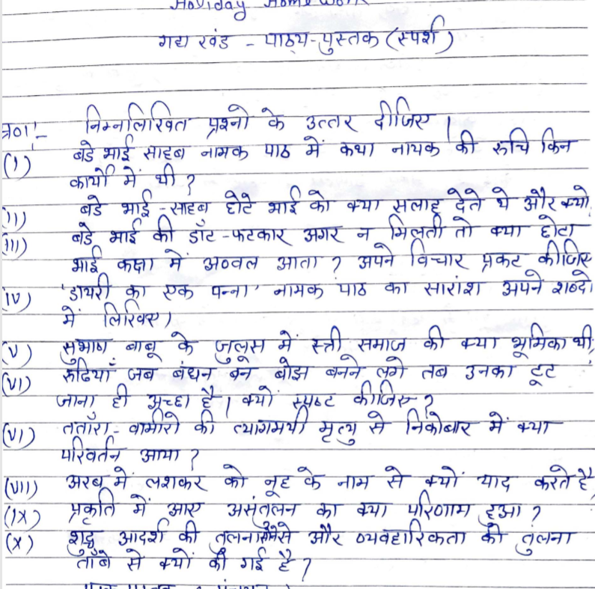
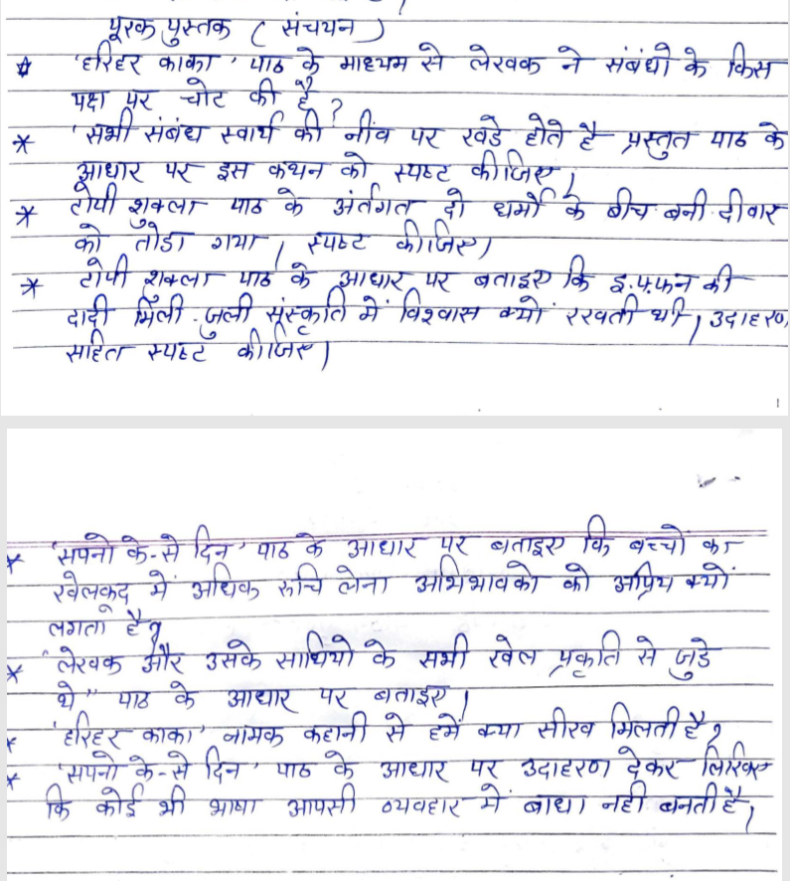
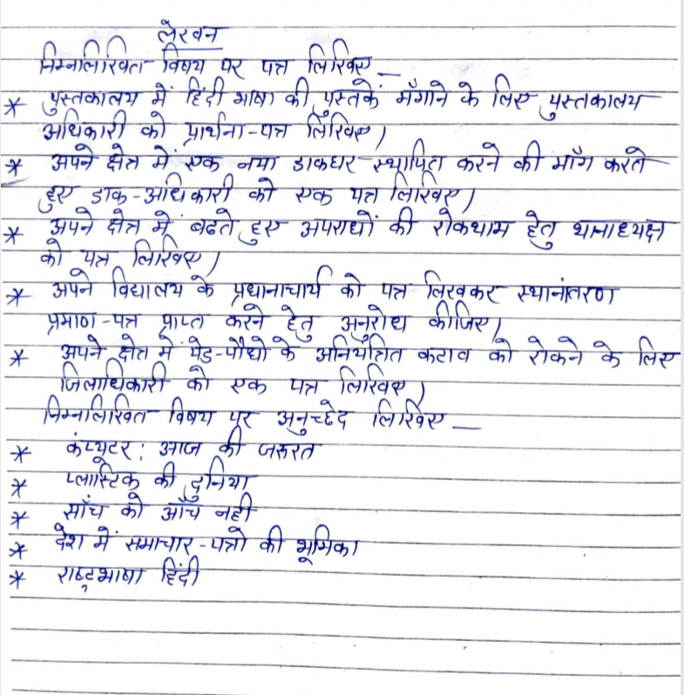
MATHS:
NOTE: Do in a separate notebook.
- Practice chapter 2, 5, 4, 7, 10.
NOTE: All the examples and exercise questions.
Q1 If α and β are the zeroes of quadratic polynomial f(x) = x²-px+q, then find the value of
- α²+β²
- 1/α+1/β
Q2 If sum of the square of zeroes of quadratic polynomial f(x) = x²+8x+k is 40, find the value of k.
Q3 Find the condition that the zeroes of the polynomial f(x) = x³-px²+qx-r may be in arithmetic progression.
Q4 If one zero of the quadratic polynomial f(x) = 4x²-8kx-9 is negative of the other, find the value of k.
Q5 Find the zeroes of the polynomial f(x) = x³-5x²-16x+80, if its two zeroes are equal in magnitude but opposite in sign.
Q6 Divide the polynomial f(x) = 30x⁴+11x³-82x²-12x+48 by 3x²+2x-4. Also find quotient and remainder and verify division alsorithm.
Q7 Find the values of a and b so that x⁴+x³+8x²+ax+b is divisible by x²+1.
Q8 Solve :
X = 1
2 - 1
2 - 1
2-x
Q9 Solve :
- 4x² – 4ax + (a² -b²) =0
- 4x² – 4a²x + (a⁴ -b⁴)=0
Q10 Solve by factorization method :-
1 = 1 + 1 + 1
a+b+x a b c
Q11 Find the roots of equation x²-(√3+1)x+√3 by the method of completing the square.
Q12 Solve by method of completing the square:
4x²+4√3x+3
Q13Solve by using quadratic formula:
1 + 2 = 4
X+1 x+2 x+4
Q14 Find the values of k for which the following equation has equal roots:
(k-12)x²+2(k-12)x+2=0
Q15 Find the value of k for which the equation x²-4x+k=0
Q16 If the equation (1+m²)x²+2mcx+(c²-a²)=0 has equal roots, prove that c²=a²(1+m²)
Q17 A two digit number is such that the product of its digits is 18, when 63 is subtracted from the number, the digits interchange their places. Find numbers?
Q18 One fourth of a herd of camels was seen in forest. Twice the square root of the herd had gone to mountains and the remaining 15 camels were seen on the bank of river. Find the total number of camels?
Q19 The denominator of a fraction is one more than twice the numerator. If the sum of the fraction and its reciprocal is 58/21, find the fraction?
Q20 The sum of squares of two consecutive odd positive integers is 394. Find them?
Q21 Determine two consecutive multiples of 3 whose product is 270?
Q22 A plane left 30 minutes later than the schedule time and in order to reach its destination 1500 km away in time it has to increase its speed by 250 km/hr from its usual speed. Find its usual speed?
Q23 Seven years ago Varun’s age was five times the square of Swati’s age. Three years hence Swati’s age will be two fifth of Varun’s age. Find their present ages?
Q24 A farmer wishes to grow a 100 m²rectangular vegetable garden. Since he has with the only 30 m barbed wire he fences three sides of the rectangular garden letting compound wall of his house act as the fourth side fence. Find dimensions of his garden?
Q25 Two pipes running together can fill a cistern in 40/13 minutes. If one pipe takes 3 minutes more than the other to fill it, find the time in which each would fill the cistern?
Q26 Determine the 10thterm from the end of the A.P. 4, 9, 14, ……….., 254?
Q27 The first term of an A.P. is -7 and the common difference 5. Find its 18thterm and general term?
Q28 Consider the A.P. 2, 5, 8, 11,…….., 302. Show that twice of the middle term of the above A.P. is equal to the sum of its first and last term?
Q29 If the 10th term of an A.P. is 52 and 17th term B is 20 more than the 13th term, find the A.P.
Q30 If the m^{th} term of an A.P. be 1/n and n^{th} term be 1/m, the show that its (mn)^{th} term is 1.
Q31 Two A.P’s have the same common difference. The difference between their 100th term is 111222333. What is the difference between their millionth terms?
Q32 Divide 32 into four parts which are in A.P. such that the product of extremes is to the product of mean is 7:15?
Q33 The ratio of the sums of m and n terms of an A.P. is m²:n². Show that the ratio of the m^{th} and n^{th} term is (2m-1):(2n-1)?
Q34 The digit of a positive integer, having three digits are in A.P. and their sum is 15. The number obtained by reversing the digit 594 less than the original number. Find the number?
Q35 Find the sum of n terms of an A.P. whose n^{th} terms is given by a_{n}=5-6n.
Q36 How many terms are there in the A.P. whose first and fifth terms are -14 and 2 respectively and the sum of the terms is 40?
Q37 Find the sum of all integers between 100 and 550, which are divisible by 9?
Q38 Find the sum of all integers between 50 and 500, which are divisible by 7?
Q39 Find :
- n and S_{n}, if a=5, d=3 and a_{n}= 50
- n and d, if a=8, a_{n}=62 and S_{n}=210
Q40 A circle is touching the side BC of a triangle ABC at P and touching AB and AC produced at Q and R respectively. Prove that
AQ= ½ (perimeter of ABC)
Q41 If the sides of a quadrilateral touch a circle, prove that the sum of a pair of opposite sides is equal to the sum of the other pair?
Q42 If PA and PB are tangents from an outside point P, such that PA=10 cm and angel APB=60⁰. Find the length of chord AB?
Q43 Two tangent segments PA and PB are drawn to a circle with centre O such that angle APB= 120⁰. Prove that OP=2AP?
Q44 Prove that the perpendicular at the point of contact to the tangent to a circle passes through the centre of circle?
Q45 Prove that length of two tangents drawn from an external point is equal?

SCIENCE:
- Answer the following:
- What is the ohm’s law? Explain how it is used to define the unit of resistance?
- When a 12v battery is connected across an unknown resistor, there is current of 2.5mA in the circuit calculate the value of resistance of the resistor?
- How does the resistance of the conductor depends on:
- Length of the conductor
- Area of cross section of the conductor.
- Temperature of the conductor
- Will current flow more easily through a thick wire of the same material, when connected to the same source? Why?
- Find the equivalent resistance in the following circuit?
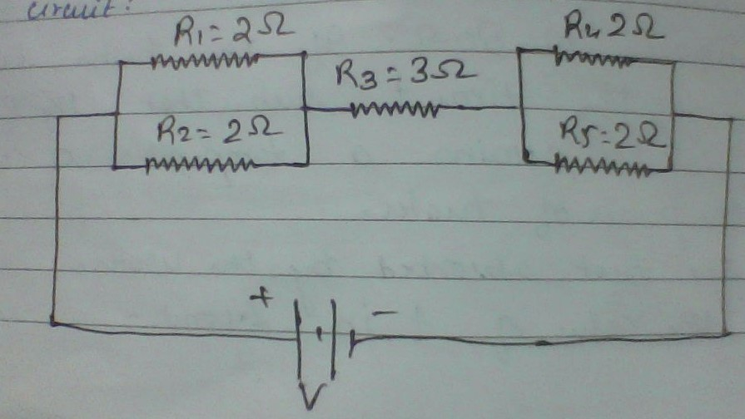
- A circuit diagram is given below: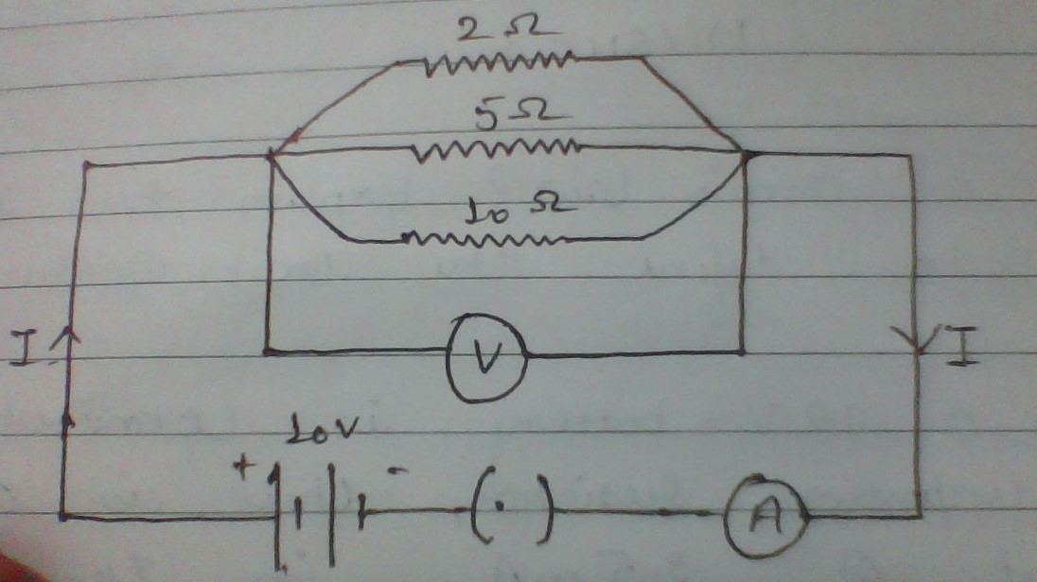

Calculate:
- The total effective resistance of the circuit.
- The total current in the circuit.
- The current through each resistor.
- What is the joule’s law of heating?
- An electric geyser rated at 1500W,250V is connected to a 250V line mains. Solve:
- The electric current drawn by it.
- Energy consumed by it in 50h.
- Cost of energy consumed if each unit costs Rs. 6
- A heater coil connected to 200V has a resistance of 80 Ω. If the heater is plugged in for the time t such that 1 kg of water at 20℃ attains a temperature of 60℃. Find:
- The power of heater.
- The heat absorbed by the water.
- The value of t in seconds.
- Answer the following:
- Which is the better way to connect lights and other appliances in domestic circuit series connection or parallel connection? Justify your answer.
- An electrician has made electric circuit of a house in such a way that, if a lamp gets fused in a room of the house, then all the lamps in other rooms of the house stop working. What is the defect in this type of the circuit wiring? Give reason.
- Define the following:
- Maxwell right hand rule.
- Fleming left hand rule.
- Fleming right hand rule.
- Explain the working of D.C. generator with its construction? (with diagram).
- Explain the principle, construction, working and diagram of A.C. generator?
- Explain the principle and working of electric motor?
- What do you mean by short circuiting and overloading?
- Why is it necessary to earth the metal appliances? What is the function of the earth wire?
- Draw a well labelled diagram of a bio-gas plant. Why is slurry left behind is considered as useful?
- Write two different ways of harnessing energy from the ocean?
- Define the process of nuclear fission. Write the steps involved in generating electricity in a nuclear reactor?
- What are the environmental consequences of using fossil fuels? Suggest the steps of minimizing the pollution caused by various sources of energy including non-conventional sources of energy causing global warming?
- Energy from various sources is considered to have been derived from the sun. Do you agree? Justify your answer.
- State one example each characterized by the following alongwith the chemical equation:
- Change in state.
- Evolution of gas.
- Change in temperature.
- Balance the following chemical equations. Write the symbols of the physical states of all the reactants and the products.
- Pb₃O₄ + HNO₃ Pb(NO₃)₂ + PbO₂ + H₂O
- C₂H₅OH + O₂ CO₂ +H₂O + Heat
- Pb₃O₄ + HCl PbCl₂ + Cl₂ + H₂O.
- Write the balanced chemical equations for the following reactions and identify the type of reaction in each case.
- In thermite reaction, iron(III) oxide reacts with aluminum and gives molten iron and aluminum oxide.
- Magnesium ribbon is burnt in an atmosphere of nitrogen gas to form solid magnesium nitride.
- A metal salt MX when exposed to light split up to form metal M and a gas X₂. Metal M is used to make ornaments whereas X₂ is used in making bleaching powder. The salt MX is itself used in black and white photography.
- Identify metal M and gas X₂.
- Mention the type of chemical reaction involved when salt MX is exposed to light.
- Decomposition reactions require energy either in the form of heat or light or electricity for breaking down the reactants. Write one equation each for decomposition reaction where energy is supplied in the form of heat and electricity.
- State the chemical reactions with chemical equations that takes place in the following:
- Magnesium wire is burnt in air.
- Electric current is passed through water.
- Ammonia and hydrogen chloride gases are mixed.
- State the reason for following:
- Small amount of acid is added to water during electrolysis of the water.
- When ammonium chloride is dissolved in water in a test tube the test tube becomes cold.
- Identify the type of reactions taking place in each of the following cases and write the balanced chemical equations for the following:
- Barium chloride solution is mixed with copper sulphate solution and a white precipitate is obtained.
- On heating copper powder in air, the surface of the copper powder turns black.
- Define rancidity. What kind of substances are used to prevent rancidity? Explain any three methods to prevent rancidity.
- Tooth enamel is one of the hardest substances in our body. How does it undergo damage due to the eating of chocolates and sweets? What should we do to prevent it?
- What are the advantages of cloth bags over plastics bags during shopping?
- We do not clean ponds or lakes but an aquarium needs to be cleaned. Why?
- State 10% law. Explain with an example how energy flows through different trophic levels.
- What are decomposers? What will be the consequence of their absence in an ecosystem?
- Our food grains, such as Wheat and Rice, the vegetables and fruits and even meats are found to contain varying amounts of pesticide residues. State the reason to explain how and why it happens?
- Reuse is better than recycling of materials.Give reason to justify this statement.
- Sustainable development implies a change in all aspects of life.Justify.
- What is a dam? Why do we seek to build large dams?
- What is the importance of forest as a resource?
- Suggest a few measures for controlling CO2 levels in the atmosphere.

SST:
Q1 What are the negative effect of human activities on resources ?
Q2 Discuss soil formation ?
Q3 Suggest any three measures of soil conservation ?
Q4 Sustainability of development is a new area of knowledge do you agree ? Justify your answer.
Q5 Explain the differences between horizontal power sharing and vertical power sharing ?
Q6 Describe any three demands of Sri lankan Tamil?
Q7 Why is power sharing desirable give any three Prudential reasons?
Q8 What do you understand by linguistic state ?
Q9 Explain the concept of of decentralization of government ?
Q10 Distinguish between coming together federation and holding together federation?
Q11 What is coalitions of government?
Q12 What happened at the Mexico Olympic games in 1968 ?
Q13 What is communalism ?
Q14 What is casteism ?
Q15 How are economic development and human development related to each other?
Q16 Explain any four different bases for comparison of economic development of different nations / States?
Q17 What is sustainable development?
Q18 Why different people having the different development goals?
Q19 Write three suggestions which create more employment in economy ?
Q20 Distinguish between primary sector secondary sector and tertiary sector?
Q21 What is disguised unemployment ?
Q22 Two difference between organised sector and unorganised sector?
Q23 Highlight two difference between intermediate goods and final goods?
Q24 What is demand deposit ?
Q25 How is money used as medium of exchange explain with example?
Q26 What is formal sector and informal sector?
Q27 Write some impact of globalisation in India?
Q28 What do you understand by multinational company ?
Q29 What do you understand by foreign investment?
Q30 Why do governments try to attract more foreign investment?

DATESHEET FOR X
12TH JULY - S.ST
13TH JULY - SCIENCE
15TH JULY - MATHS
16TH JULY - ENGLISH
17TH JULY - HINDI
NOTE:
Missing any exam will attract penalty of rupees 1000 per subject for any reason.
SYLLABUS FOR INTERNAL ASSESMENT FOR BOARD’S
CLASS X

- Mathematics:-
- Chapter 2- Polynomials
- Chapter 4- Quadratic Equation
- Chapter 5- Arithmetic Progression.
- Chapter 7- Coordinate Geometry.
- Chapter 10- Circles.
2)Science:-
- Physics:- i)Electricity
ii)Magnetic Effect of Electric Current.
iii) Sources of Energy.
- Chemistry:- i)Chemical Reaction and Equation.
ii) Acid, Bases and Salts.
- Biology:- i) Our Environment.
ii) Management of Natural Resources.
3)Hindi:-
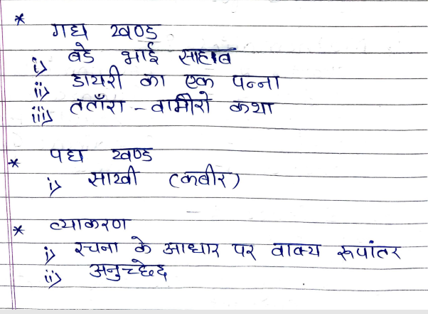

4) English:-
- First Flight:-ch-[1-6]
- Poetry:- ch- [1-6]
- Supplementary:-ch-[1-4]
5) Social Studies:-
- Geography:-i) Resources and Development.
- Civics:- i)Power Sharing.
ii) Federalism.
iii) Democracy and Diversity.
- Economics:- i) Development.
ii) Sectors of Indian Economy.
iii) Money and Credit.

For any query you can call to Mr. Rahul Khanna on this number +917895026334 only between 10.30am to 11.30am

