The Royal College
Winter Holiday Homework 2023-24
Class – 4th

Dear Parents

Vacations are not only meant to explore the world outside but also are an opportunity to rediscover ourselves while we stay at home. So, embark on a journey of fun and adventure by reading books, exercising, meditating, dancing and channelizing your energy in a positive manner.
The Winter Vacation has begun. To keep our students engaged in fun based learning activities we have compiled a set of activities for the Winter Vacation. You may have to help your child to complete the home-work.
Kindly make sure that your child submits the homework to their respective class teacher/ subject teachers as per the submission dates suggested.

English-
*Modest Education (Holiday Worksheet)
Page no :- 15 to 33
- Write 10 sentences on your own using helping verbs on A4 size paper. Example:- is, am, are, was were etc.
- Make a table mat of an A3 size sheet with some interesting tongue twisters written on it. Decorate it nicely and get it laminated.
Learn & write the following topic in your English holiday homework notebook for your upcoming declamation competition.
Expressing gratitude

The emotion that makes you want to thank someone and return the favour is gratitude.
The word gratitude has "gratus" as its root, which signifies thankfulness.
Gratitude fosters society's tendency to be charitable. In society, gratitude fosters harmony, peace, and cohesion.
We stop comparing ourselves to others when we are grateful. As a result, it encourages contentment and helps us accept our own blessings and triumphs.
It is the most potent source of inspiration that anyone can access if they simply pause and pay attention to the understated wonder and magic of life. As a result, it has the capacity to change your life. to communicate personally in today's fast-paced
No one has time environment. By expressing gratitude, one can bridge this gulf in social relations.
It has been demonstrated psychologically that practising thankfulness is good for one's mental health.

There may be several kinds of thankfulness depending on to whom and for what it is expressed; nonetheless, the core motivation behind gratitude is
the same in the great majority of situations.-to be appreciative. Being grateful to those you love is an act that strengthens your bond with
them and contributes to a happy and contented community.
It increases the feeling of respect and recognition and the trust element.

Hindi- हमारी भाषा (व्याकरण) पेज नंबर 40,41, 42, 43, 44, 45.
क्रियाकलाप- “योगा का महत्व” विषय पर एक पोस्टर बनाएं।

Mathematics-
- Modest Education (complete your worksheet of Mathematics)
Activity 1- Take 10 different 6 Digit numbers and write them in expanded form.
Activity 2- Draw a digital clock using colourful chart paper.
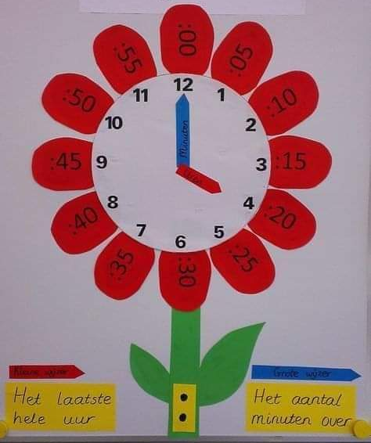

EVS-
Modest Education (Holiday Worksheet)
Worksheet- G.K. Page No. 75 to 88
Activity-
1. Collect four different leaves, flowers and seeds dry them between newspaper folds and paste them in a scrapbook. Write 3-4 lines about each.
2. Make your own first aid box. You can use an old shoe box. With the help of your parents get the things to put inside.
It should contain the following things
- Cotton
- Bandage
- Band-aid
- Scissors
- Dettol
- Antiseptic Cream
For any query you can call to Mrs.Pinky Aswal on this number +917668624014 only between 10.30 am to 11.30am.

